## Dashboard Design Report

### Interactive Data Visualisation

### SET09123

Andrew Taison

Matriculation: 40538519

Word | Page count: 1751 | 6

(excl. references and appendices)

Submission date: 23rd November 2023

Table of Contents

Introduction and Description 1

Visualisations 2

Interactions 3

Layout 5

Insights 6

References 7

Appendices

Appendix A – Default Dashboard Layout A

Appendix B – Major Charts: Levels, Max Data and Scaled Axes B

Appendix C – Minor Chart: Single Line Chart C

Appendix D – Station Selection Effects D

Appendix E – Pie Centre Effects E

Appendix F – Layout Thought Process F

# Introduction and Description

Recognising that statistics on their own can overlook the complete narrative and miss underlying patterns or trends, leads us to the understanding that it is important to provide visualisations. By providing visual representations of the data, users can gain a better understanding of it along with reducing cognitive effort required to do so. Visualisations also allow users to explore a dataset more intuitively.

The role of a Data Scientist has been undertaken to design and implement a dashboard for the purpose of analysing a weather dataset sourced from weather stations across the UK. The aim is to create an interface for users to explore the data for marketing purposes whilst also providing a good user experience (UX). This report discusses the design decisions and thought processes of the visualisations and available interactions provided.

To begin with, a question about the data was posed:

*“How does the weather vary across different locations of the UK on a monthly and yearly basis, and are there any noticeable trends?”*

The dashboard design throughout has been motivated by keeping UX in mind, prioritising ease of use and allowing for a comprehensive exploration of the data. The experience should be simple and intuitive, putting a focus on keeping chart clutter to a minimum. This has lead to allowing the user to navigate views via clicks and double clicks rather than adding additional buttons. Some buttons have been included, however these aid cognitive effort by displaying which state the chart is currently in to the user. It is thought that temperature and rainfall are key weather attributes as these significantly affect daily life, and so the dashboard has been created with a focus on these. As location is suspected to be a large factor in changing weather, a focus on weather stations is also included.

# Visualisations

The following visualisations have been included, and each is followed by a short description about why it has been included in the design. The interactions section covers what data is displayed in more detail as interactions modify this. The dashboard default display as seen when first loaded is shown in Appendix A.

**Bar Chart (Precipitation over time):**

This chart allows for a quick comparison of average rainfall across time periods. This provides a visual representation of how rainfall varies month to month or year to year for a particular month on average. A bar chart is good for comparing values across different categories. Although the categories here are temporal, it works well for allowing entities to be visually distinct. Patterns or anomalies can be easily identified.

**Scatter Plot (Precipitation vs Temperature):**

The scatter plot helps to explore any relationship (if one exists) between the major weather attributes (temperature and precipitation) across different time periods and identify any correlations or trends.

**Line Chart (Sun hours/Air Frost over time):**

The line chart provides an overview of the average weather conditions over the months across the years for the minor weather attributes (sun hours and air frost days). This chart is useful to help identify any patterns or trends that may exist.

**Multi-line Chart (Temperature over time):**

This chart is well suited to identify variations in multiple weather attributes, in this case, highest for period, lowest for period, and average for period temperatures. It allows for comparison of the attributes and shows if the highs and lows are correlated.

**Map Bubble Chart (Geographical Station Map):**

The underlying map has been adapted from Interactive Data Visualisation practical 9 [1]. Overlaying the bubble chart on a map provides a good geographical perspective of weather stations. Each bubble size represents that stations average temperature across the years allowing the user to quickly recognise differences by location for average temperatures.

**Sun Burst Chart with Pie Centre (Weather Attributes by Location Split):**

This chart provides a hierarchical view of the weather variations based on different splits (median latitude or median longitude). A central UK split location was considered, however it was found the stations are not well distributed around this point (see lines 157-175 main.js). The pie centre shows the distribution of each split (number of stations and number of data points). The inner ring shows each month, and the leaf nodes show each weather attribute (after being normalised for easy comparison). This allows for a good overview of how weather attributes vary across different locations. The sunburst chart has been adapted from a basic sunburst tutorial on GitHub [2].

# Interactions

The majority of the visualisations included have multiple views accessible by clicking chart content. Below discusses the different interactions for each visualisation available along with what data is displayed upon doing so. Appendix A shows the default dashboard as viewed when the first loaded.

**Bar Chart, Scatter Plot and Multi-Line Chart:**

Each chart mentioned has similar views and interactions. The data displayed is based on averages from the entire dataset:

* Default view - Each bar/dot represents a month averaged across the years. To access second level, click one of the bars/dots.
* Second level view – Displays for a specific month (the one selected) where each bar/dot represents a year average. To access third level, click one of the bars/dots.
* Third level view – Displays for a specific year (the one selected) where each bar/dot represents a month average. Clicking a bar/dot here will take the user back to the second level view.
* Double click - Resets to default view.
* Max data axis/scaled axis radio buttons – Defaults to max data axis which displays data using an axis calculated from the data maximum. Scaled Axis allows for a zoomed in view.

These interactions allow users to explore monthly variations across different years and, in turn, yearly variations for specific months. The max data axis aids the user to identify variations and understand where the data lies in comparison to the data’s maximum values, whilst the scaled axis allows the user to view cluster points easily.

Appendix B shows each view level for these charts with max data and scaled axes.

**Single Line chart:**

* Dropdown box - Provided to switch between sun hours data and air frost days data.

These weather attributes are considered to be minor in regards to the posed question and so less interactions and hence less detail is provided in the visualisation compared to others. The visualisation is still included to provide a broader overview of the overall weather variations. Appendix C shows each dropdown option selected.

**Bubble Map:**

* Clicking a bubble - Changes all the above mentioned charts to show data regarding only that specific weather station.
* Zoom – Allows for a better look at each stations location.
* Double click – Resets selected station to none. Note, selecting another station will deselect the previous station.

The ability to select a station allows users to explore in more detail how weather varies by location. Appendix D shows the dashboard before and after a station is selected.

**Pie Centre (of Sun Burst):**

* Clicking the centre – This will rotate the pie/sun burst and change the colouring of the station bubbles to match.
* Zoom – Allows for a better look at various aspects and segments of the visualisation.

These allow differences to be viewed in the sun burst chart between a north/south split and an east/west split around the data median. Appendix E shows the dashboard before and after clicking the pie centre.

**Tooltips:**

Available in all visualisations for providing additional, and more detailed information on data points.

**Shared Highlighting:**

All visualisations (except bubble map) provide shared highlighting on connected data points (months and years). Highlighting is still included on the bubble map (along with all other visualisations) which gives feedback to the user as to which datapoint they are hovering over.

All of these interactions provide users with a powerful and flexible toolset to explore and analyse the weather variations across different locations in the UK.

# Layout

The layout has been designed with a focus on the major visualisations (those showing temperature and precipitation data). The scatter chart is top centre. To the left and in line with the average rainfall axis is the precipitation bar chart. Directly beneath the scatter and in line with the average temperature axis is the multi-line temperature chart. These allow the users eyes to naturally flow and compare values from one visualisation to the next.

The minor chart (for sun hours and air frost data) is shown bottom left as it is of lesser significance.

Finally the charts regarding locations and which give a broader overview of the data are shown to the right allowing these to be in a natural grouping. Appendix F shows the thoughts behind the layout in a visual way.

Semantic colours have been used where possible for the various attributes in the sunburst, using representative colours for each weather attribute (red=temperature, yellow=sun, blue=rain, grey=air frost). For the north/south split, the north stations are mainly in the north of England and Scotland, with the south being mainly England and Wales. So blue has been used for the north and orange for the south. In the east/west split, the stations are fairly spread out in the west, so due to Ireland being thought of as in the west, green has been used. England makes up the stations in the east, so red has been used. For the other visualisations, soft pascal colours have been used. It was considered to use the same colours as used in the sunburst for respective chats, but this looked too busy and messy, so was cut down to a more uniform colour set.

# Insights

Below are some brief insights from the data exploration:

* Typically temperatures start increasing from late winter/early spring (Jan/Mar), whilst precipitation starts to fall until around mid/late spring (April/May). Precipitation starts to rise again whilst temperature continues to rise until mid/late summer (Jul/Aug). At this point, temperature begins to fall, whilst precipitation continues to rise until the end of the year. It appears that a rise or fall in temperature is followed by a delayed rise or fall in precipitation respectfully (around 3 months or so). This cyclic patten can be clearly seen in the scatter plot (scaled view).
* On average, the west receives 20mm more rain than in the east. Whilst the north receives approximately 15mm more rain on average than the south. This can be seen in the sunburst chart.
* Average rainfall is around 1/3 to 1/4 of the highest on record, recorded by Eskdalemuir station, December 2015. Also, note this station records the lowest temperatures in December 2010. On average, Eskdalemuir records higher than average rainfall and lower than average temperatures.

# References

1. P. Le Bras, "Practical 9 – Maps," *Edinburgh Napier*, SET09123. 2023.
2. D. Richards, “A No Frills Sunburst,” *GitHub.* Online. Available:

<https://gist.github.com/denjn5/e1cdbbe586ac31747b4a304f8f86efa5>.

# Appendix

# Appendix A – Default Dashboard Layout

Figure 1 below shows the default dashboard as it is when first loaded.

Figure 1. Default Dashboard

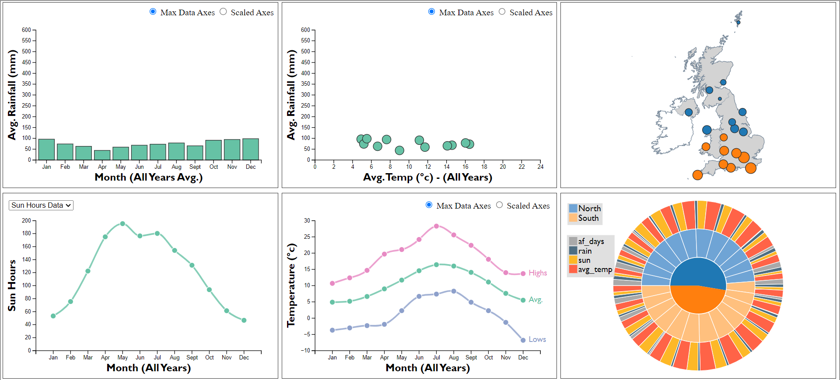

# Appendix B – Major Charts: Levels, Max Data and Scaled Axes

The major charts (Bar, Scatter and Multi-Line) are shown below (Figures 2-19) for each of their view levels with max data axes and scaled axes.

**Bar Chart:**

Figure 2. Bar Chart, Default View, Max Axes Figure 3. Bar Chart, Default View, Scaled Axes

Figure 4. Bar Chart, 2nd Level View, Max Axes Figure 5. Bar Chart, 2nd Level View, Scaled Axes

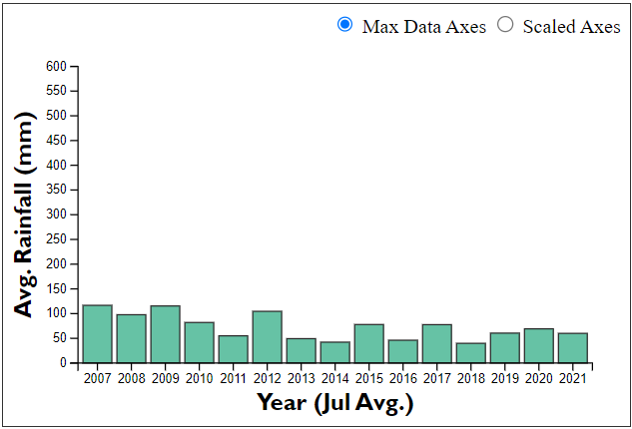 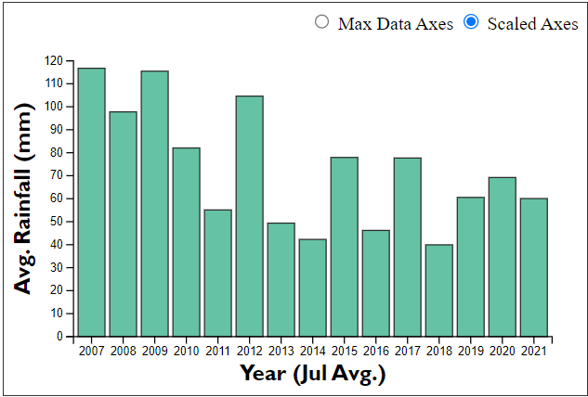

Figure 6. Bar Chart, 3rd Level View, Max Axes Figure 7. Bar Chart, 3rd Level View, Scaled Axes

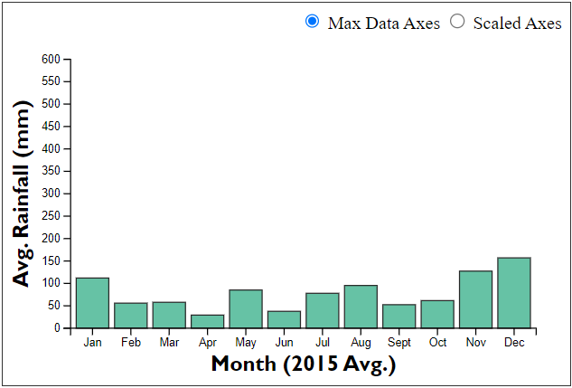 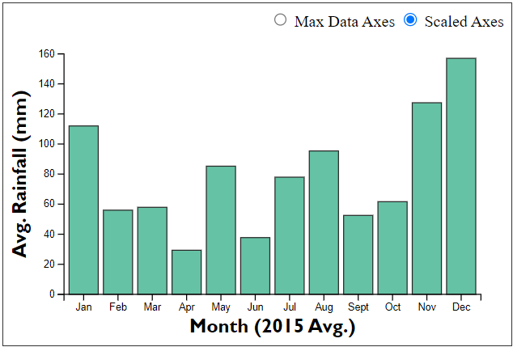

**Scatter Plot:**

Figure 8. Scatter Plot, Default View, Max Axes Figure 9. Scatter Plot, Default View, Scaled Axes

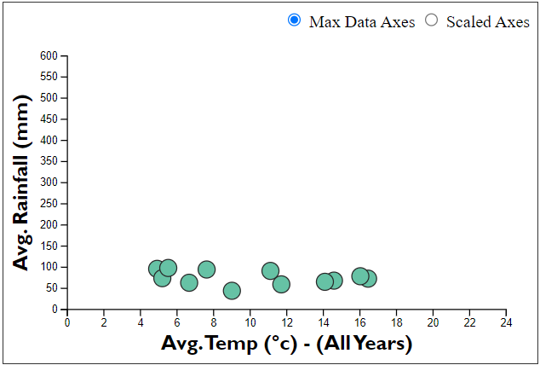 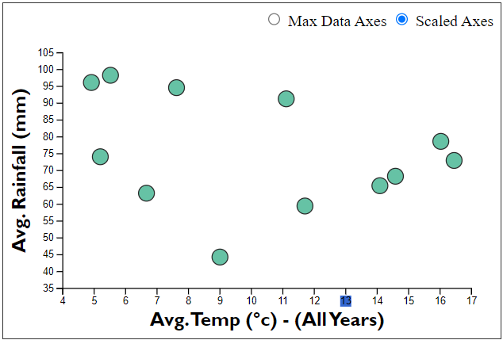

Figure 10. Scatter Plot, 2nd Level View, Max Axes Figure 11. Scatter Plot, 2nd Level View, Scaled Axes

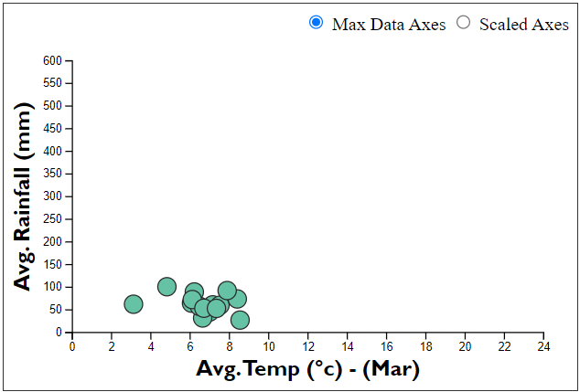 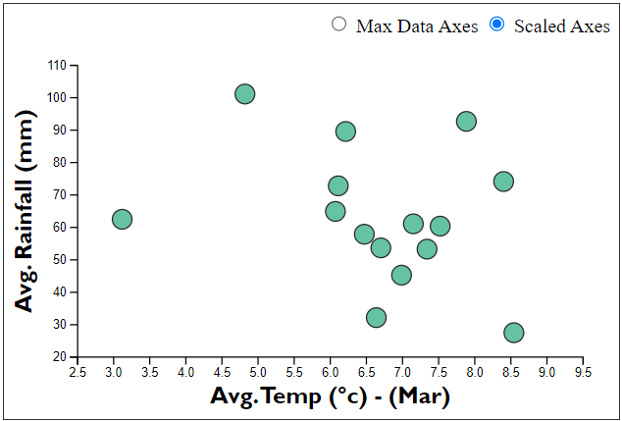

Figure 12. Scatter Plot, 3rd Level View, Max Axes Figure 13. Scatter Plot, 3rd Level View, Scaled Axes

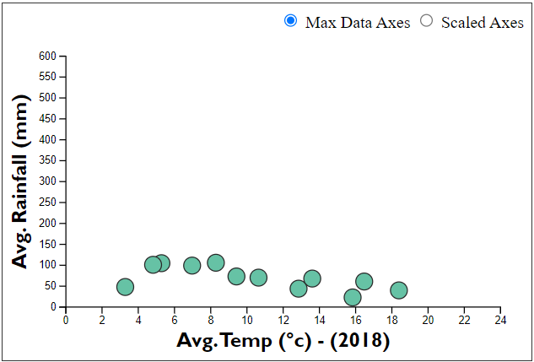 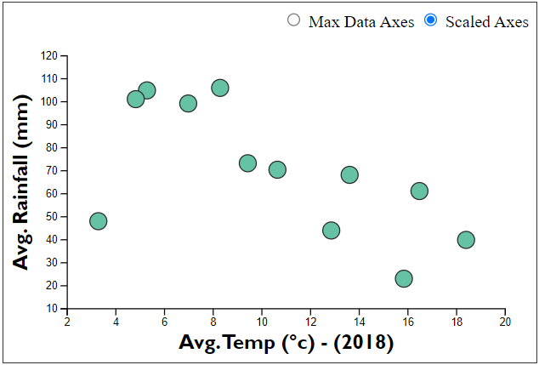

**Multi-Line Plot:**

Figure 14. Multi-Line Plot, Default View, Max Axes Figure 15. Multi-Line Plot, Default View, Scaled Axes

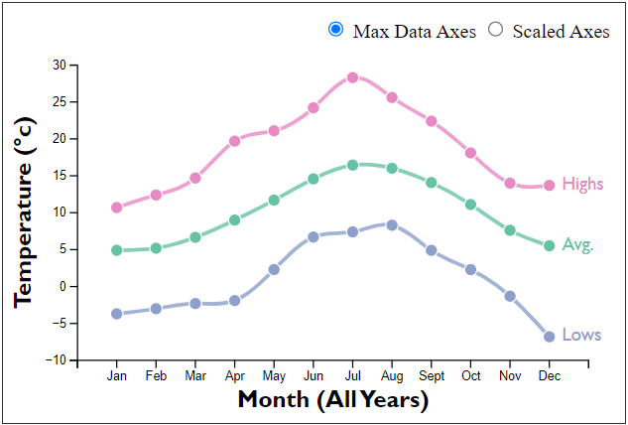 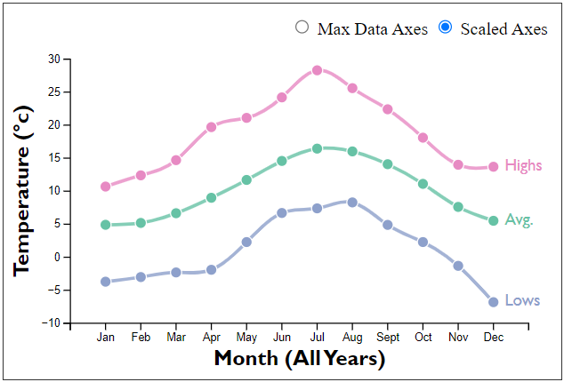

Figure 16. Multi-Line Plot, 2nd Level View, Max Axes Figure 17. Multi-Line Plot, 2nd Level View, Scaled Axes

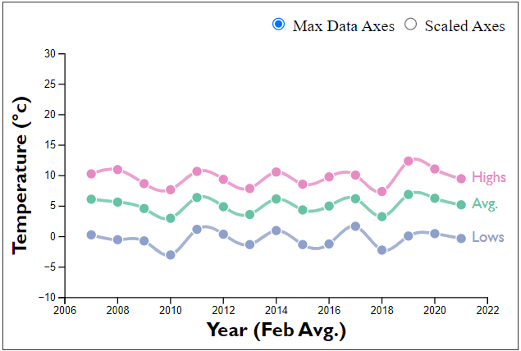 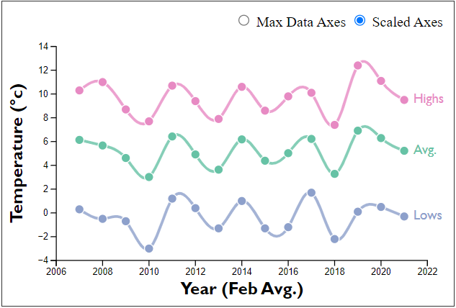

Figure 18. Multi-Line Plot, 3rd Level View, Max Axes Figure 19. Multi-Line Plot, 3rd Level View, Scaled Axes

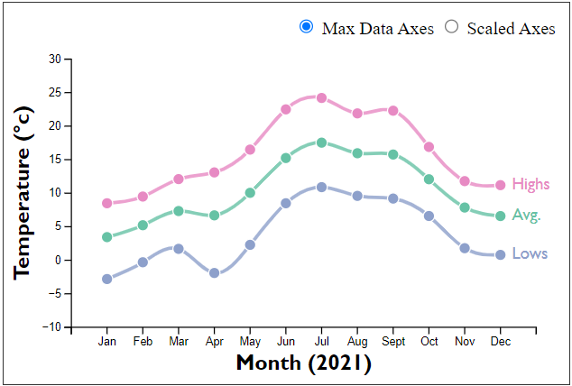 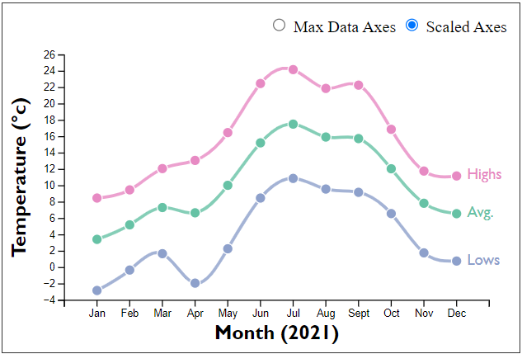

# Appendix C – Minor Chart: Single Line Chart

Below Figures 20 and 21 show the single line chart with each option selected from the dropdown for the different data types (sun hours and air frost).

**Single Line Chart:**

Figure 40. Single Line Chart, Sun Hours Figure 21. Single Line Chart, Air Frost Days

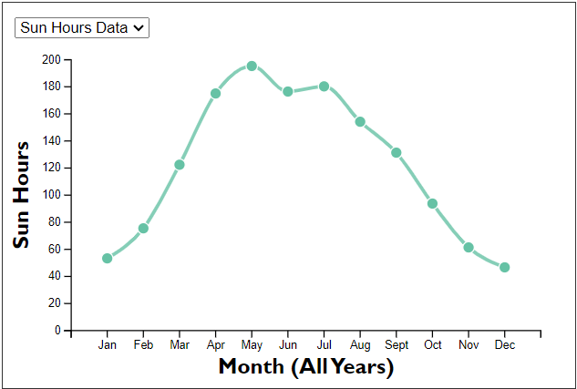 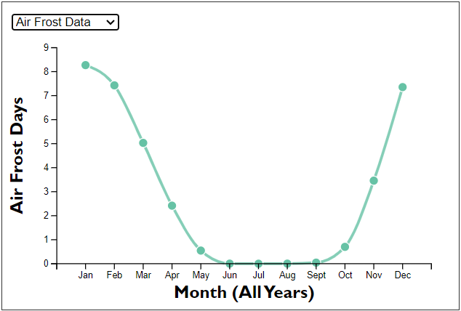

# Appendix D – Station Selection Effects

Figure 22 below shows the dashboard (with various views and axes) before a station is selected, and Figure 23 shows the dashboard after.

Figure 22. Before Station Selected

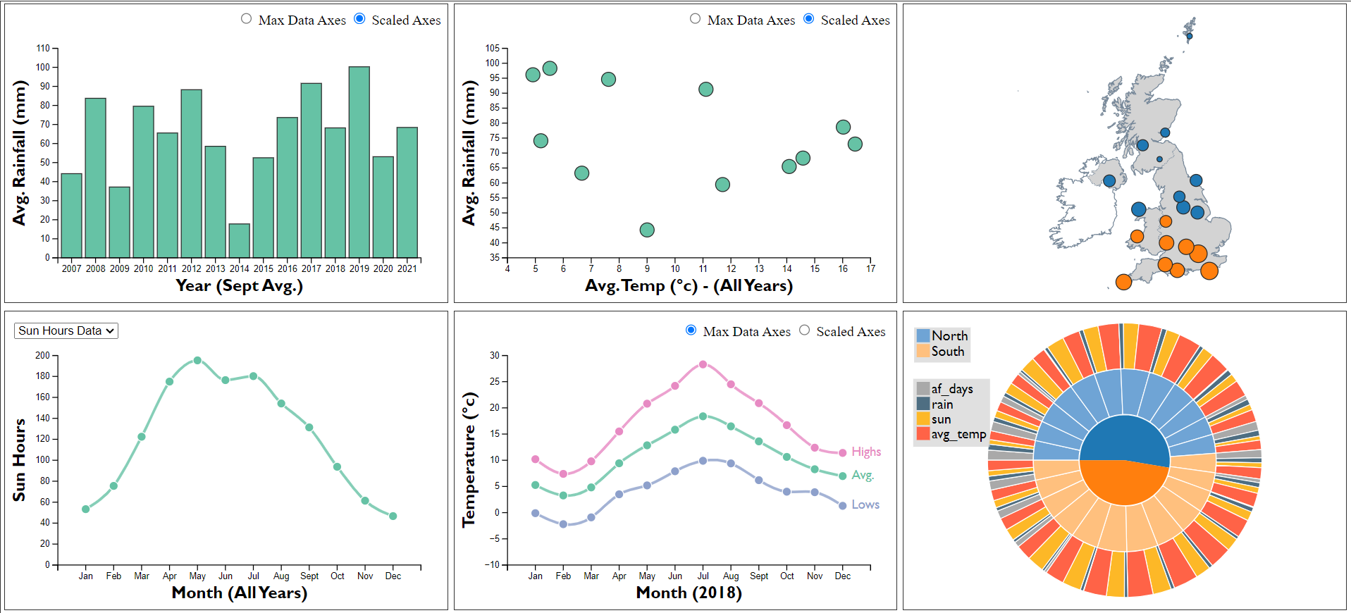

Figure 23. After Station Selected

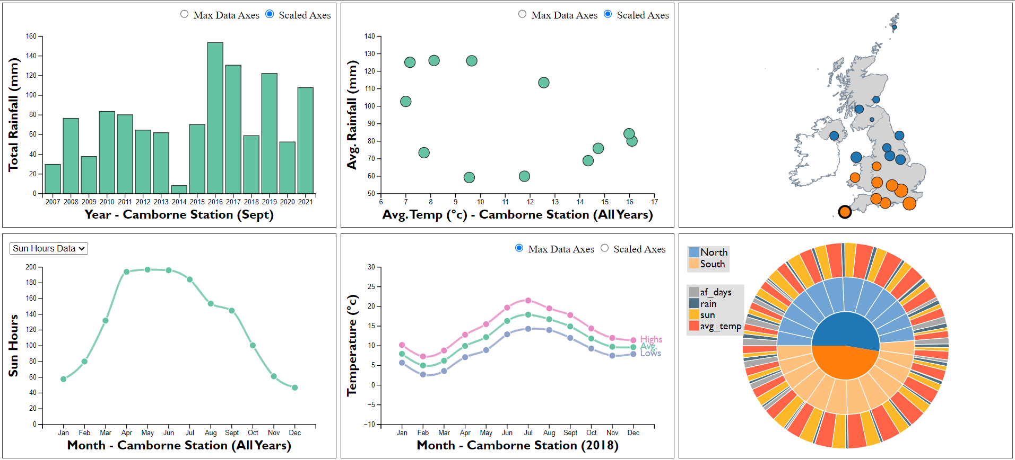

# Appendix E – Pie Centre Effects

Figure 24 below shows the dashboard (with various views and axes) before the pie centre is clicked, and Figure 25 shows the dashboard after.

Figure 24. Before Pie Centre Clicked

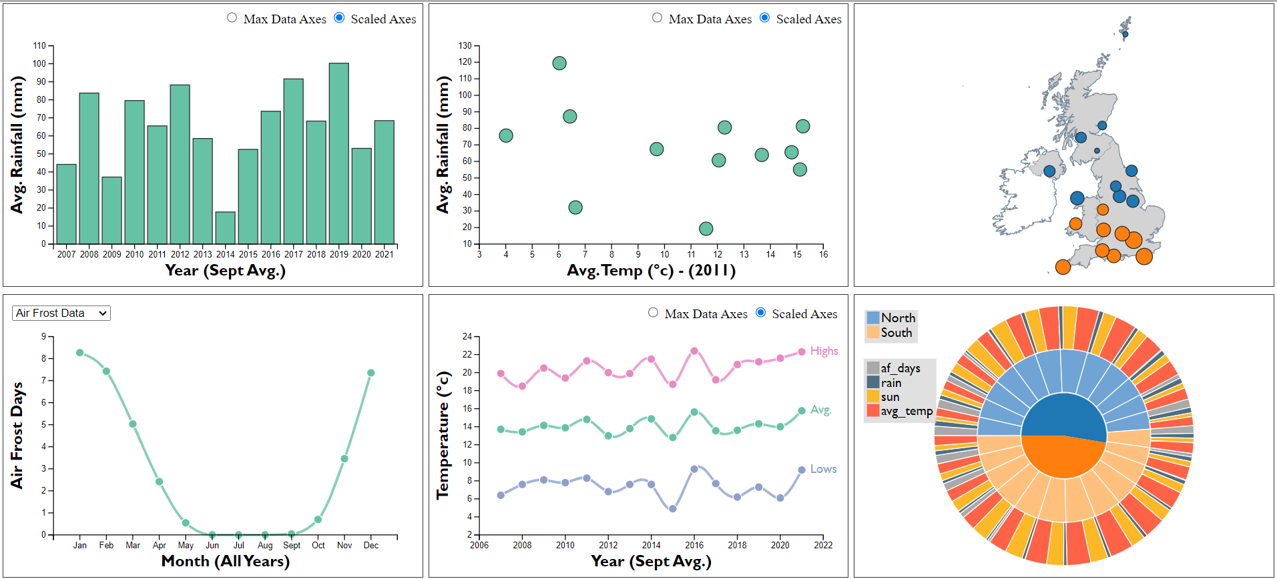

Figure 25. After Pie Centre Clicked

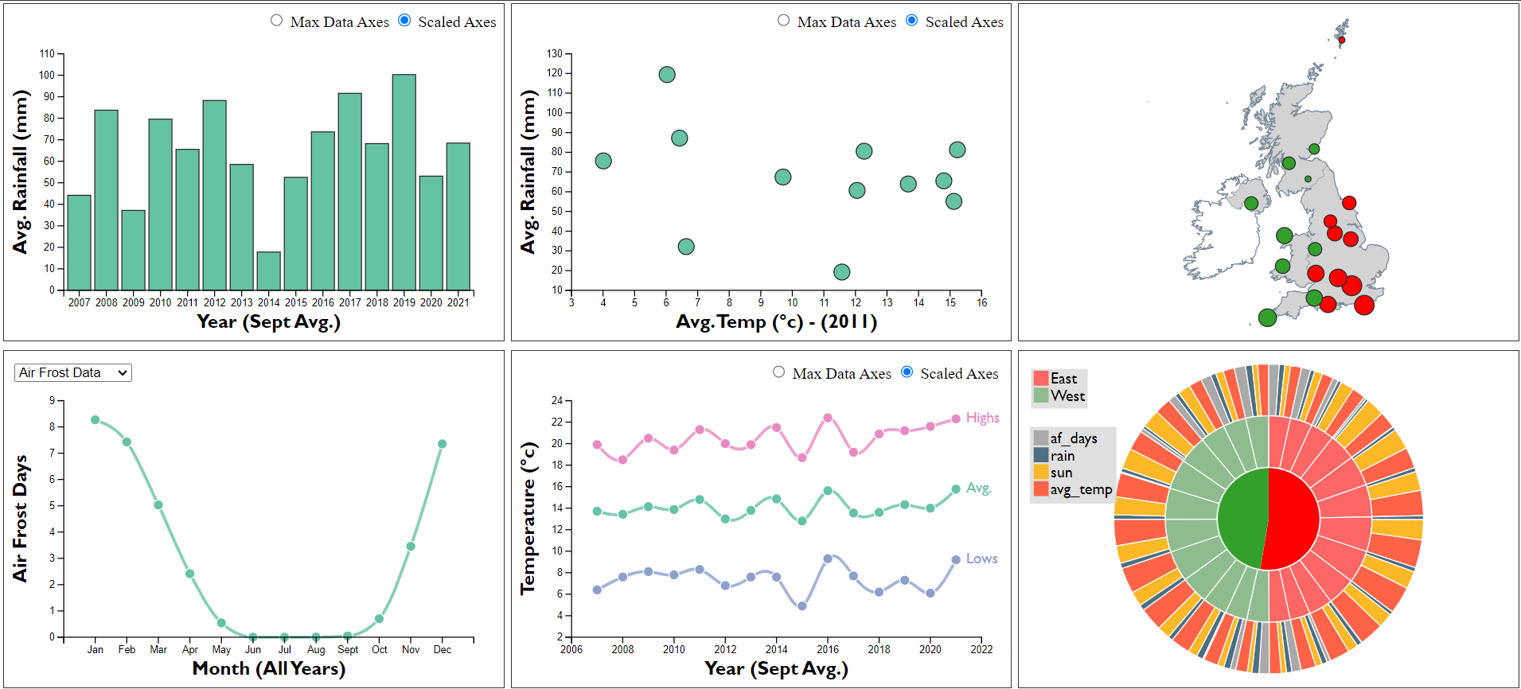

# Appendix F – Layout Thought Process

Figure 26 below shows the natural flow connections between the major charts.

The four data charts form grouping themselves (the three highlighted, plus air frost/sun single line chart).

Figure 27 shows how the location related charts form a natural grouping and provide a general overview of stations and location data, they almost act as a control panel to the side.

Figure 26. Major Chart Natural Flow Connections

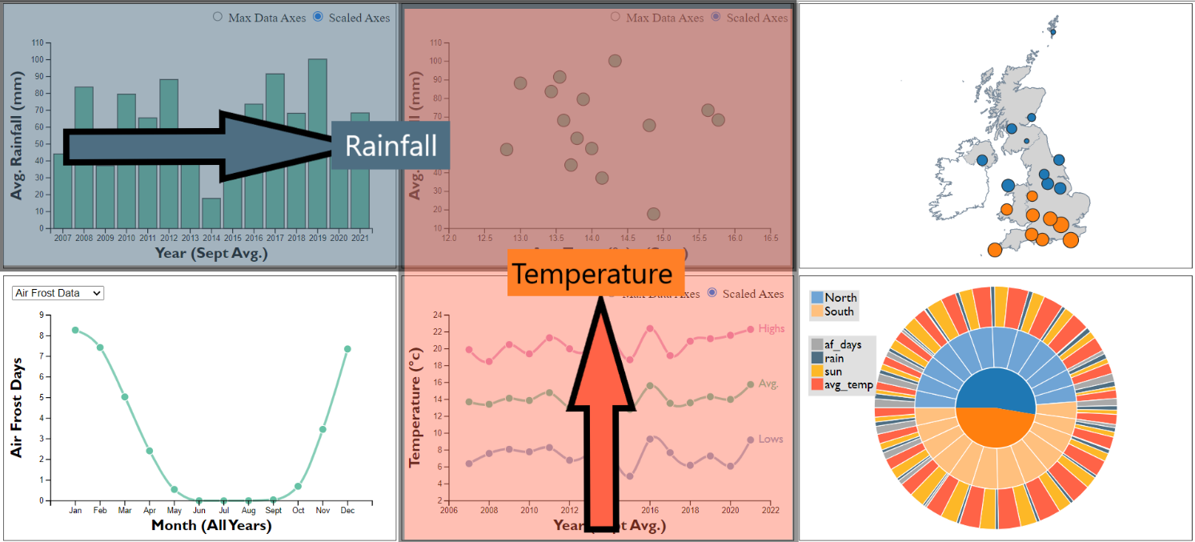

Figure 27. Location Charts Natural Grouping

